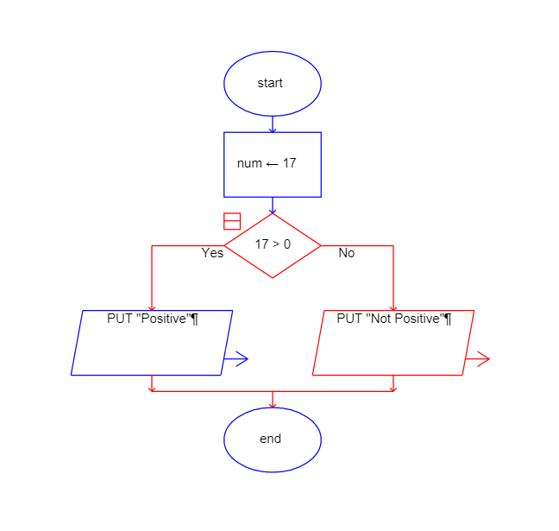
Lab Assignment 1
1. Check Positive Number:

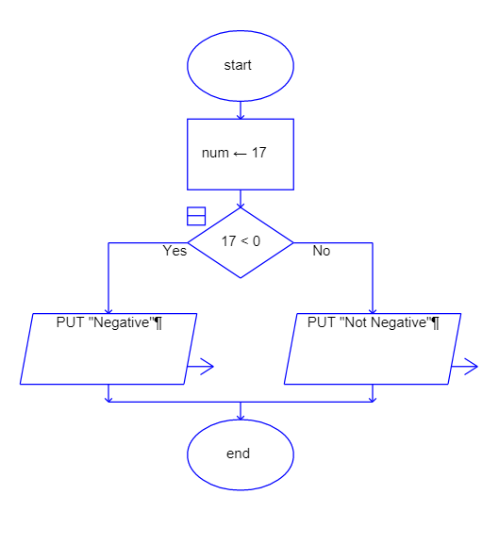
2. Check Negative Number:

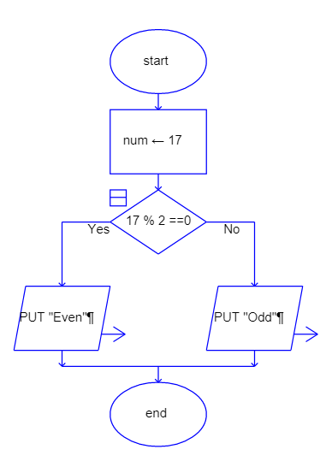
3. Check Odd or Even Number:

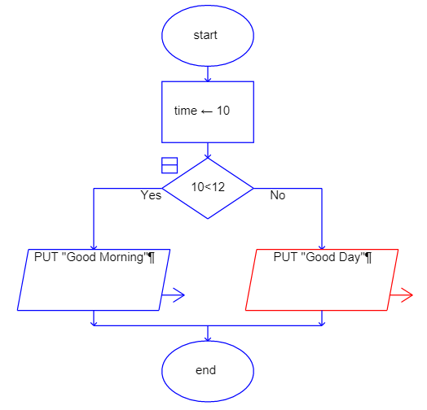
4. Display Good Morning Message Based on Time:

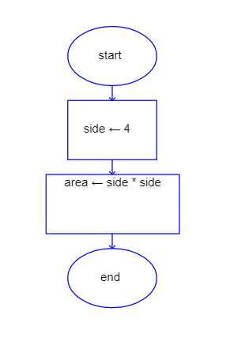
5. Print Area of a Square:

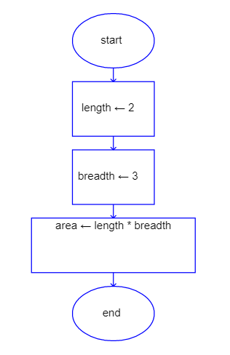
6. Print Area of a Rectangle:

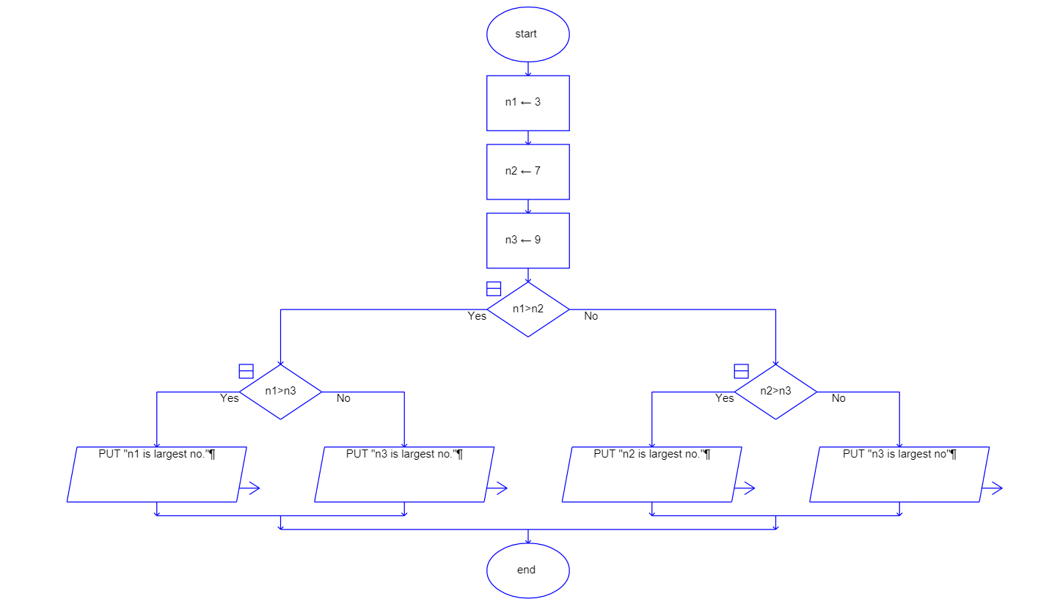
7. Find the Largest of Three Numbers:

